Starting docker

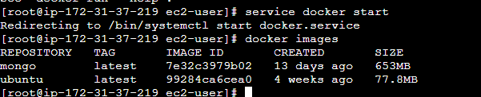

creating

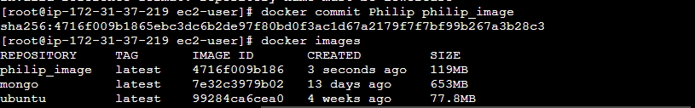

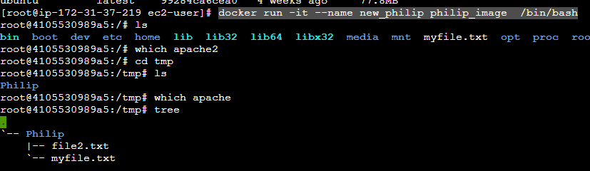

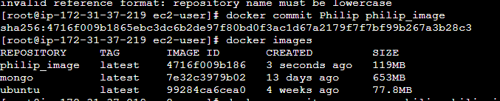



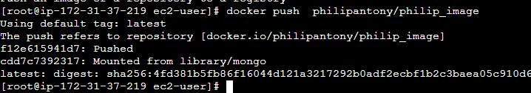

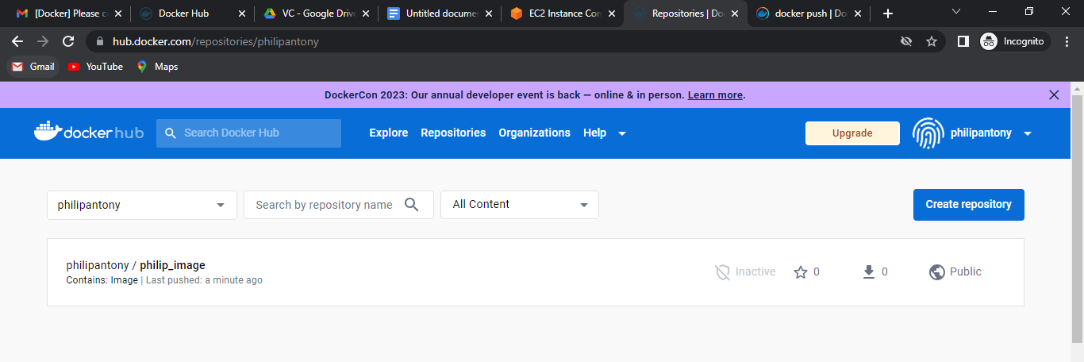

Pulling image from dockerhub

